Lesson Title: Isolating Microbes
Grade level = Middle or High (adustiable) Amount of time for this lesson = This lesson is broken down into four days: one 90 minute day for block, three 50 minute day for data analysis and research.

Standards and Safety and Materials:
A. Standards - (Both Wyoming and NGSS. Number and write it out) | Chemistry:  - Middle School:  - MS-PS1-1. Develop models to describe the atomic composition of simple molecules and extended structures.  - High School:  - HS-PS1-2. Construct and revise an explanation for the outcome of a simple chemical reaction based on the outermost electron states of atoms, trends in the periodic table, and knowledge of the patterns of chemical properties.  - HS-PS1-6. Refine the design of a chemical system by specifying a change in conditions that would produce increased amounts of products at equilibrium.  Biology:  - Middle School:  - MS-LS1-1. Conduct an investigation to provide evidence that living things are made of cells; either one cell or many different numbers and types of cells.  - MS-LS4-6 Use mathematical representations to support explanations of how natural selection may lead to increases and decreases of specific traits in a population over time.  - MS-ETS1-1 Define the criteria and constraints of a design problem with sufficient precision to ensure a successful solution, taking into account relevant scientific principles and potential impacts on people and the natural environment that may limit possible solutions.  - High School:  - HS-LS4-2: Construct an explanation based on evidence that the process of evolution primarily results from four factors: (1) the potential for a species to increase in number, (2) the heritable genetic variation of individuals in a species due to mutation and sexual reproduction, (3) competition for limited resources, and (4) the proliferation of those organisms that are better able to survive and reproduce in the environment.  - HS-LS4-4: Construct an explanation based on evidence for how natural selection leads to adaptation of populations.  Earth Science:  - Middle School  - MS-ESS3-4. Construct an argument supported by evidence for how increases in human population and per-capita consumption of natural resources impact Earth's systems.  - High School  - HS-ESS2-2. Analyze geoscience data to make the claim that one change to Earth's surface can create feedbacks that cause changes to other Earth systems  Physics:  - High School  - HS-PS2-6: Communicate scientific and technical information about why the molecular-level structure is important in the functioning of materials.  - HS-PS3-6: Create or apply a computational model to calculate the change in the energy of one component in a system when the change in energy of the other component(s) and energy flows in and out of the system are known.
B. Safety Concerns: If none – “minimal safety concerns with regular class activity” | - Gloves, goggles, and lab coats should be worn at all times to prevent any substance from getting on one’s person.  - Heat caution when using fire to sterilize instruments.  - Wash hands after lab to prevent contamination and to practice clean lab safety.
C. Materials (List of all materials needed for class including technology – like probes, tools, computer use, etc…) | Basics for Lab:  - 1 Lab Worksheet per student  - 3 Nutrient Agar Petri Dishes (times however many groups you have)  - 3 MacConkey Agar Petri Dishes (times however many groups you have)  - 6 cotton swabs (times however many groups you have)  - Hand soap  - Antibacterial hand disinfectant  - Sterile loop (one per group)  Technology:  - Incubator  Demo + Practice:  - Practice worksheet  - Colored pencils or regular pencils

- Objectives: (List them and make sure all are measurable! Bold the verbs. Three different levels!) Students will be able to…
A. SWBAT… use a measurable verb | Chemistry:  - Identify bacteria using a dichotomous key  - Use this information to research what the chemical composition of this organism is and relate it to the successful survival of the organism.  - Know the importance and relevance of the catalase test  - How does this reaction work?  - What does it tell us about the organism?  - Determine the outcomes of bacteria grown on MacConkey agar  - Why do gram negative bacteria grow?  - How is this related to pH and acid production?  - Proper lab techniques  - Streaking  - Sterilization  - Cleanliness and contamination precautions  Biology:  - Relate bacteria growth rates and environment  - Why do only some bacteria grow on certain agar plates?  - Ideal temperature for growth  - Observe and predict bacteria life cycles  - Rapid growth  - Compare similarities and differences between bacterial cell and human cells  - Draw conclusions about antibiotic resistant microbes:  - Good? Bad? Ugly?  - Proper lab techniques  - Streaking  - Sterilization  - Cleanliness and contamination precautions  Earth Science:  - Understanding the important role that microbes play in keeping the Earth healthy  - No microbes = no breathable oxygen  - Food digestion depends on microbes  - Knowing many microbes are found in different mediums  - Comparing harmful versus Beneficial Bacteria  - Where are they located?  - How can people/animals in those areas avoid them?  Physics:  - Calculating growth rates  - Calculating half life  - Calculating death rates

- Connections, Misconceptions, and Crosscutting Concepts:
A. Real world connections: (List them; e.g. Careers, Societal issues, etc…) | Microbes are in everything! Being able to differentiate between harmful and non-harmful bacteria is an important skill that both scientists, engineers, and regular people can apply. By being able to classify microbes, people can know what they are prone to, how to prevent it, and further help the human race expand their life expectancy across the globe.
B. Student connections: (List them; With what do they connect? Music, food, etc…) | This takes students down a unique road to show them the germs, bacteria, and microbe world around us by specifically focusing on their hands. It brings in a personal connection that can’t get any closer than students’ swabbing their own hands.
C. Misconceptions: (List those AAAS misconceptions related to your content) | -All microbes are bad. https://www.microbe.net/simple-guides/microbial-myths-common-misconceptions-about-microbes-in-the-built-environment/
D. Crosscutting Concepts: (List them and explain how they are used – e.g. patterns, cause/effect, scale/proportion/quantity, systems/system models, energy/matter, structure/function, and/or stability/change) | Patterns: students can see and predict patterns by washing their hands with soap versus using antibacterial soap.  Cause and Effect: Students will be able to visually see the differences between the three methods of hand washing in relation to bacteria outcomes.
E. Academic Language: [List the words/prefixes/suffixes that are addressed (focus on science vocabulary as well as instructions such as analyze, compare/contrast, etc…). What will the teacher do? How does the teacher address the words/prefixes/suffixes? How does the teacher get students to use those words, prefixes, and/or suffixes?]

- Catch/Engagement: (Hook them quickly – use all 5 senses at different times – should be no longer than 5 minutes.)
Hook: How to get student/class attention | Watch a YouTube video of bacteria on our hands or 15 Horrifying Microscopic Images: https://www.youtube.com/watch?v=Q7po-L8eGYM

- Pre-test: (Same as post-test and short – to the point… Bold the objectives you are using – same as above!)
Pre-test and Post-test question(s)  Put the pre-test at the end of this day’s lesson plan (along with PowerPoint etc…)! | Attached worksheet for biology based lesson

- Activity/Exploration: (Bold the verbs that match the objectives. Can have as many parts as needed – step by step directions.
(Remember: Include at least 1 science writing activity and probe activity for the unit!)
- Beginning of lesson | Pre Test (different for each subject matter, example can be seen for Biology attached)
Day One: Introduction, Lecture, and Streaking | Lecture (see SWBAT objectives to form your lecture)  - Chemistry  - Biology  - Earth Science  - Physics  Proper Techniques: Demo + Practice Handouts  - Safety techniques  - Proper streaking techniques for inoculating bacteria on agar  - Make sure to include proper sterilization techniques  - Practice with Handout  - Students will demonstrate the correct way, direction, and pressure of streaking by using a crayon/pencil and a paper circle  - Teacher must approve and address issues before moving on  Data Collection: Lab Worksheet  - Split students into groups of 4  - Designate rolls: -Sample Student  -Swabber  -Supervisor  -Washer  - Teacher will had each group 6 pre-labeled Petri dishes (MacConkey and Nutrient Agar)  - Begin with the “unwashed” Petri dish.  - From the Sample Student, a second group member, the Swabber, should gently rub a cotton swab on the surface of that student’s palm. Do not lay the cotton swab down.  - The Supervisor should open the “unwashed” Petri dish containing agar.  - The Swabber should gently rub the cotton swab sample taken from the unwashed hand back and forth on the agar.  - **Be careful not to apply too much pressure when doing this, otherwise the agar will tear.**  - The Supervisor should close the Petri dish.  - The fourth group member, the Washer, should carefully wash one hand of the Sample Student’s hands with soap and water.  - The Swabber and Supervisor should repeat Steps 4-6 for this hand; being careful to streak the dish labeled “washed” and “sanitized”.  - **It’s important that all the samples come from the same person to reduce experimental error**
Day Two: Isolation and Analysis | Data Analysis: Worksheet Continued  - Students will begin the period reviewing the growth of their bacteria by answering the questions on their lab handouts.  Isolation  - Lecture:  - Talk about the isolation process and the importance and relevance of having a single colony  - Show the different types of possible bacteria  - Continue to build off your discipline specific objectives  - Students will take their grown bacteria and try to isolate the many different types within it.  - The goal is to try to isolate one colony.  - If the students streaked properly on the first day, a single colony can be obtained  - Streak a single colony onto a separate petri dish
Day Three: Main Takeaways, Review, and Research Project Introduction | Main Takeaways: Now that we have isolated at least one type of bacteria, here is what each discipline will do with that information, please modify to fit your beginning PowerPoint and Objectives for your discipline. These are merely examples:  - Chemistry: Research Project  - What is your bacteria made out of in terms of chemical composition?  - How is this chemical composition useful for the organism’s survival?  - What is the role of the catalase test in this experiment?  - What is the importance of the MacConkey agar?  - Biology: Comparisons  - What was the growth rate observed between the three different samples?  - What is the life cycle of bacteria?  - Similarities and Differences between microbes and human cells.  - For higher education classes: how can the use of antibacterial sanitizer be harmful in the grand scheme of things?  - Earth Science: Predictions  - Where else could you find your bacteria? Why are these locations a population spot?  - Research  - How could the climate possibly change your bacteria?  - Physics: Calculations  - Predict growth rate  - Predict half life and decay rates
Day Four: Making Real World Connections | Data Corral: Make Real Connections  - Visit DataCorral.edu to have students search for other places where they might find the same bacteria on their hands.  - Make connections as to why this type of bacteria would be able to live there.  - Make predictions as to how the students could have come into contact with this bacteria.
- End of lesson | Finish lab reports. Post test.

- Review/Essential Questions/Explanation: (Should be closely related to pre/post tests!)
A. Low Level Questions – (Knowledge/Remembering and/or Comprehension/Understanding) | Can you describe the basics of microbe growth in relation to the hands in terms?
B. Middle Level Questions – (Application/Applying and/or Analysis/Analyzing) | How will you prepare an investigation to isolate your microbes?
C. High Level Questions – (Synthesis/Evaluating and/or Evaluation/Creating) | How will you be able to defend your hypothesis based on the data you gathered?

- Assessments (Post-test)/Evaluation: (Bold the verbs that match the objectives and are in the activity.)
A. Formative: (Check for learning in class?)  e.g. Oral questions? | Verbal questions throughout the lesson as well as the Pre-test.
B. Post-test: ( “Same as pre-test”; Compare w/pre-test to inform teaching!) | Pre/Post test questions will be up to the discrepancy of the teacher in their specific science discipline.
C. Summative: (Check for final learning/understanding) – e.g. Students turn in constructed project and take 20 question multiple choice test. | The lab itself will serve as a summative assessment. This will help determine whether or not the students will be able to isolate the microbes, and make connections in their given discipline.  The lab report will be designed by the teacher in order to assess the students’ understanding of the overall scientific concepts below, as well as integrating their specific subject into the assessment to complete the disciples objectives:  - Objective of the lab  - Directions  - Data acquisition table (days can vary depending upon instructor)  - Bacterial growth table  - Reflection questions pertaining to specific discipline
D. Explain how the data informs tomorrow’s teaching. For example, “The class post-test average must be a 80% or the next class begins with a 10 minute review/discussion of today’s material followed by another post-test of the same material.” | This four day lab exercise serves to introduce students to a wide array of techniques, including proper lab techniques, data collection and analysis, key laboratory research practices, and the applications of science subjects in career paths through the context of standard and knowledge through lessons in class. Some key takeaways that will be valuable towards the rest of the year, as well as towards the rest of their science careers as students include:  Overall:  - Knowledge of how to write a lab report by conveying data to form analysis and conclusions.  - Knowledge of proper isolation techniques, plating techniques, and analysis techniques of microbes.  - A key understanding of how all the pieces of the science work together in research.  Please see discipline objectives for further clarification of each subject outcomes.

- Timeline for your lesson:
A. Catch 2 min  B. Pre-test 3 min  C. Activity – 4 parts 40 min  D. Review and Post-test 8 min  Add/change as needed | This lesson plan is modified to fit a whole week’s worth of activities, given that you have a block day in the week. Each day consist of three 50 minute period with one 90 minute block day, for four toal days.  Day One: Lecture and Streaking, 50 minutes  Day Two: Microbe Isolation, 90 minutes  Day Three: Lecture and Takeaways, 50 minutes  Day Four: Data Corral Research

- Enrichment/Elaboration: (Include one enrichment activity for students that might finish early)
What enrichment activities are offered for students in this lesson (beyond what is taught)? | Students may write up a condensed version of their takeaways from the project and/or of their results for the school newspaper and/or class science journal, if applicable.

- IEP Accommodations/Differentiation/Diversity: What accommodations will you use to support struggling learners?
What accommodations are used to support struggling learners? | Students will work in groups, so students who are struggling with the content will have a chance to work at their Zone of Proximal Development and thus learn at a higher level than they would if they were working alone. Students who need more time for the project can be given time either before or after school with help from the teacher to find sources that will support their group’s plan.

Supplemental Materials are based from a Biology perspective, please adapt your materials accordingly as the given guidelines for objectives above in SWBAT to align with the Standards for your discipline and grade level.
Pre/Post Test:

Name: ____________________________________ Date: __________________________

Bacteria are Everywhere!
Pre/Post-Assessment Bacteria Survey

Directions: Please answer the following questions to the best of your ability, using your knowledge of bacteria and their growth.
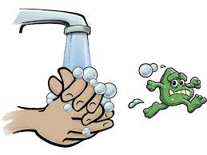
1) Name three factors that bacteria need for their growth.
a) ______________________________________
b) ______________________________________
c) ______________________________________

2) The following questions are True or False. Circle your choice.
- Bacteria only grow in the dark. T F
- Hand sanitizer kills 100% of the bacteria on your hands. T F
- Bacteria are only found in dirt.
T F

Lecture

 | 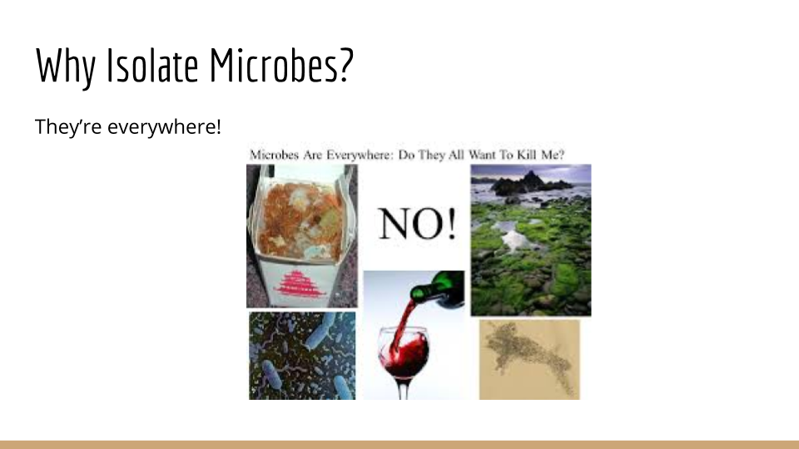 | 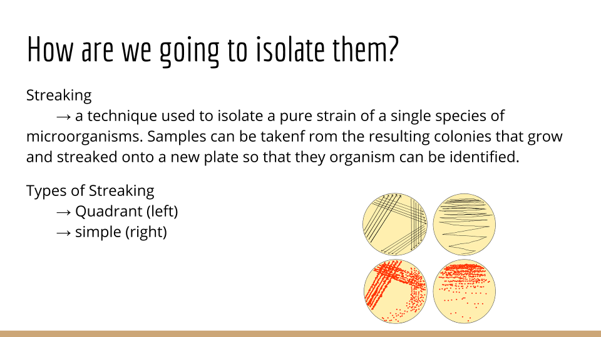
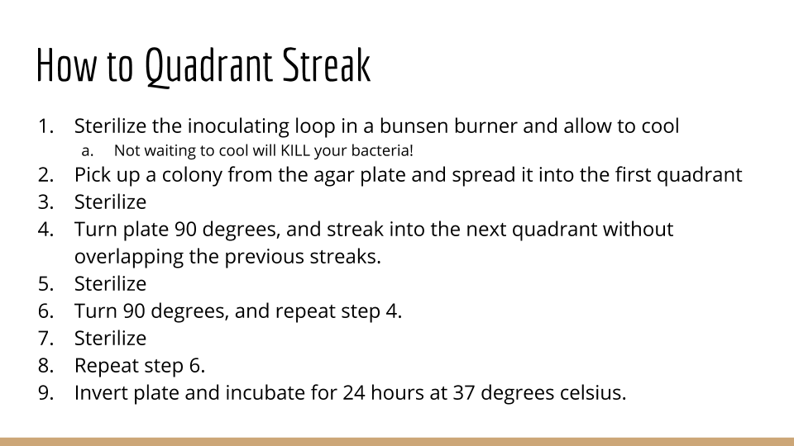 | 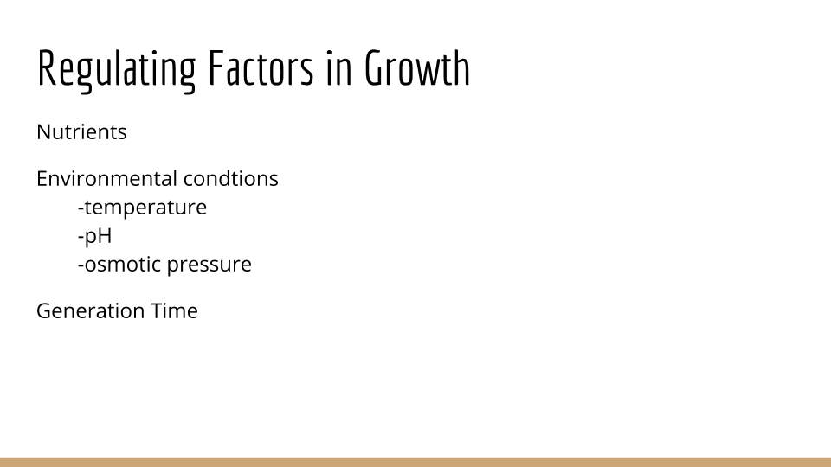 | 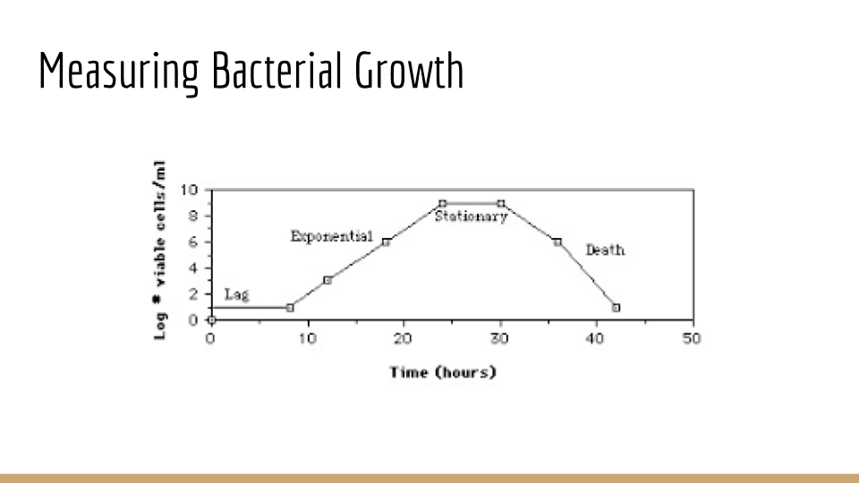

Lab Report
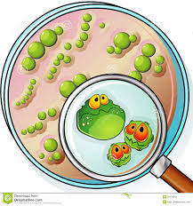
Bacteria are Everywhere!
Lab Report
Directions
Lab Report modified from TeachEngineering.org
How effective is washing your hands or using hand sanitizer on removing bacteria? Let’s find out.
Samples of bacteria will be collected from the surface of your hands and the bacterial will be grown over time. To reduce experimental error, the samples should be taken from one student’s hand only, but under three different conditions:
1. Unwashed hand
2. Hand washed with soap and water
3. Hand sanitizer with antibacterial hand gel

Answer the following questions to summarize your experimentation results.
1. Which sample showed the most growth of bacteria? Was this the result that you expected?
________________________________________________________________________
________________________________________________________________________
________________________________________________________________________
________________________________________________________________________
________________________________________________________________________
________________________________________________________________________
2. Did any bacteria grow on the sanitized hand? If so, do you agree with the common slogan that many antibacterial hand gel brands state, “Kills 99.9 % of bacteria!”?
________________________________________________________________________
________________________________________________________________________
________________________________________________________________________
________________________________________________________________________
________________________________________________________________________
________________________________________________________________________
3. What do you think would happen if you were to steak plates with bacterial samples from other common surfaces, such as a doorknob, kitchen counter, railing near the subway/train? Comment on what you might expect based on your results.
________________________________________________________________________
________________________________________________________________________
________________________________________________________________________
________________________________________________________________________

